**A**

**Project Based Learning**

**Information Technology Management (ITM)**

**On**

# **“UPI OTP System Using**

# **2 Factor Authentication”**

**Submitted By**

|  |  |  |  |
| --- | --- | --- | --- |
| Roll No. | PRN no. | Seat No. | Name |
| 27 | 2214110260 | 2422930541 | R Gokul |
| 11 | 2214110244 | 2422930527 | Ekansh Garg |
| 22 | 2214110255 | 2422930537 | Kumar Sarthak |
| 59 | 2214110368 | 2422930565 | Aditya Tripathi |

**Under the Guidance of**

**Prof. T.B. Patil**

**Department of Information Technology**

**BHARATI VIDYAPEETH (DEEMED TO BE UNIVERSITY) COLLEGE OF ENGINEERING, PUNE-411043**

**(Academic Year 2023-2024)**

# BHARATI VIDYAPEETH

# (DEEMED TO BE UNIVERSITY)

# COLLEGE OF ENGINEERING,PUNE

**DEPARTMENT OF INFORMATION TECHNOLOGY**

**Certificate**

This is to certify that the work under Synopsis for the topic “UPI OTP System Using 2 Factor Authentication” is carried out by “Ekansh Garg, R.Gokul, Kumar Sarthak, Aditya Tripathi” under my guidance in partial fulfillment of the requirement for the degree of “Bachelor of Technology in Information Technology Semester-IV” of “Bharati Vidyapeeth (Deemed to be University), Pune” during the academic year 2023-2024. To the best of my knowledge and belief this work has not been submitted elsewhere or the award of any other degree.

Date: - 18-04-2024

# Prof. T.B.Patil Dr. Sandeep Vanjale PBL Guide HOD IT

**ACKNOWLEDGEMENT**

It was a pleasure doing the project work which helped us discover new things and explore research related areas. This became possible only due to experienced guidance and the inspiration that helped us to complete this work. The successful completion of this project could not have been possible without the help and guidance of many people.

We express our grateful and sincere appreciation and deep gratitude to our PBL Guide Prof. T.B. Patil for his valuable guidance, constant encouragement, and contribution in completion of this project and for giving us an opportunity to prepare on this interesting topic.

We are grateful to our Head of Department of Information Technology, for supporting us and motivating us for the work which has been carried out here.

We would also like to express gratitude to our beloved Principal, Prof. Dr. Vidula Sohoni Madam for providing access to the required resources and the Internet for collecting information for this report.

Last but not the least this acknowledgement would be incomplete without rendering our sincere gratitude for blessings of our parent and friends who have always been a source of inspiration & motivation, without which this project work would not have been possible.

We proudly thank Almighty God for his blessings!

Ekansh Garg

R.Gokul

Kumar Sarthak

Aditya Tripathi

B.Tech. (IT) Semester – IV

**INDEX**

|  |  |
| --- | --- |
| Sr. No. | Title |
| 1 | Overview |
| 2 | Need of UPI system |
| 3. | Original Code |
| 4. | Project on implementing two factor authentication for UPI system |
| 5. | Program Description and Explanation |
| 6. | References |

# INTRODUCTION: -

Imagine a super-smart digital payment system that makes sending and receiving money as easy as shooting off a text message. That's pretty much what the Unified Payments Interface (UPI) is all about. Launched in India, UPI lets you transfer funds between bank accounts instantly using just a smartphone. It's like having a digital wallet that's hooked up to your bank account, but without the hassle of entering long account numbers and IFSC codes. With UPI, you can pay bills, split restaurant tabs, shop online, or even send money to a friend in a jiffy. It's secure, convenient, and has revolutionized the way people handle transactions in India, becoming the go-to choice for millions.

# Need of UPI system of payment:

Here are some key points elaborating on the need for UPI:

1. Simplicity and Convenience: Traditional banking methods often required individuals to input lengthy account numbers, IFSC codes, and other details for fund transfers, which could be cumbersome and prone to errors. UPI simplifies this process by allowing users to transfer money using just a virtual payment address (VPA), which is easy to remember and share.
2. Real-Time Transactions: Unlike traditional bank transfers that can take several hours or even days to process, UPI enables instant fund transfers between bank accounts, even outside of regular banking hours and on holidays. This real-time capability is especially useful for urgent transactions or when immediate payment settlement is required.
3. Interoperability: UPI is designed to be interoperable across different banks and payment service providers, allowing users to send and receive money seamlessly, regardless of the bank or platform they are using. This eliminates the need for both parties to have accounts with the same bank or mobile wallet, promoting financial inclusivity and convenience.
4. Security: UPI transactions are secured using two-factor authentication, typically a combination of a unique UPI PIN and biometric verification (such as fingerprint or iris scan) on the user's smartphone. This multi-layered security approach helps prevent unauthorized access and ensures the safety of transactions, instilling trust among users.
5. Encouraging Digital Payments: With the increasing penetration of smartphones and internet connectivity, there is a growing demand for digital payment solutions that are easy to use and widely accepted. UPI fulfills this need by providing a modern, mobile-first payment infrastructure that encourages individuals and businesses to adopt digital transactions over traditional cash-based methods.
6. Promoting Financial Inclusion: UPI plays a crucial role in promoting financial inclusion by providing access to banking services for underserved populations, including those in remote areas or without access to traditional banking infrastructure. By enabling low-cost, hassle-free transactions through smartphones, UPI empowers individuals to participate in the formal economy and access essential financial services.

# CODE :

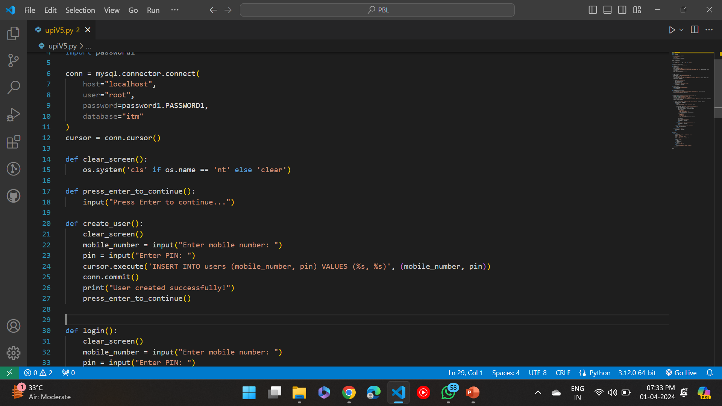

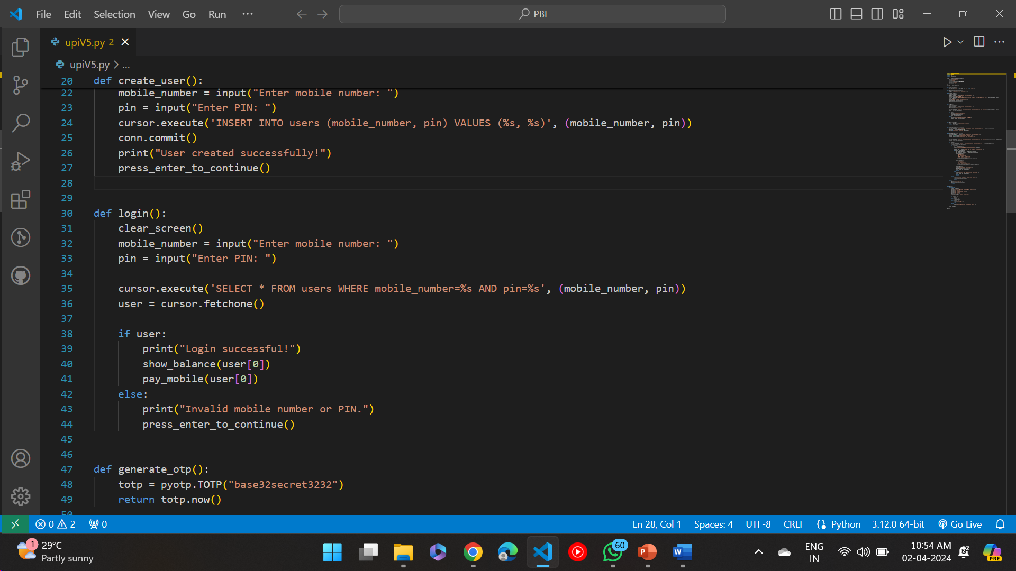

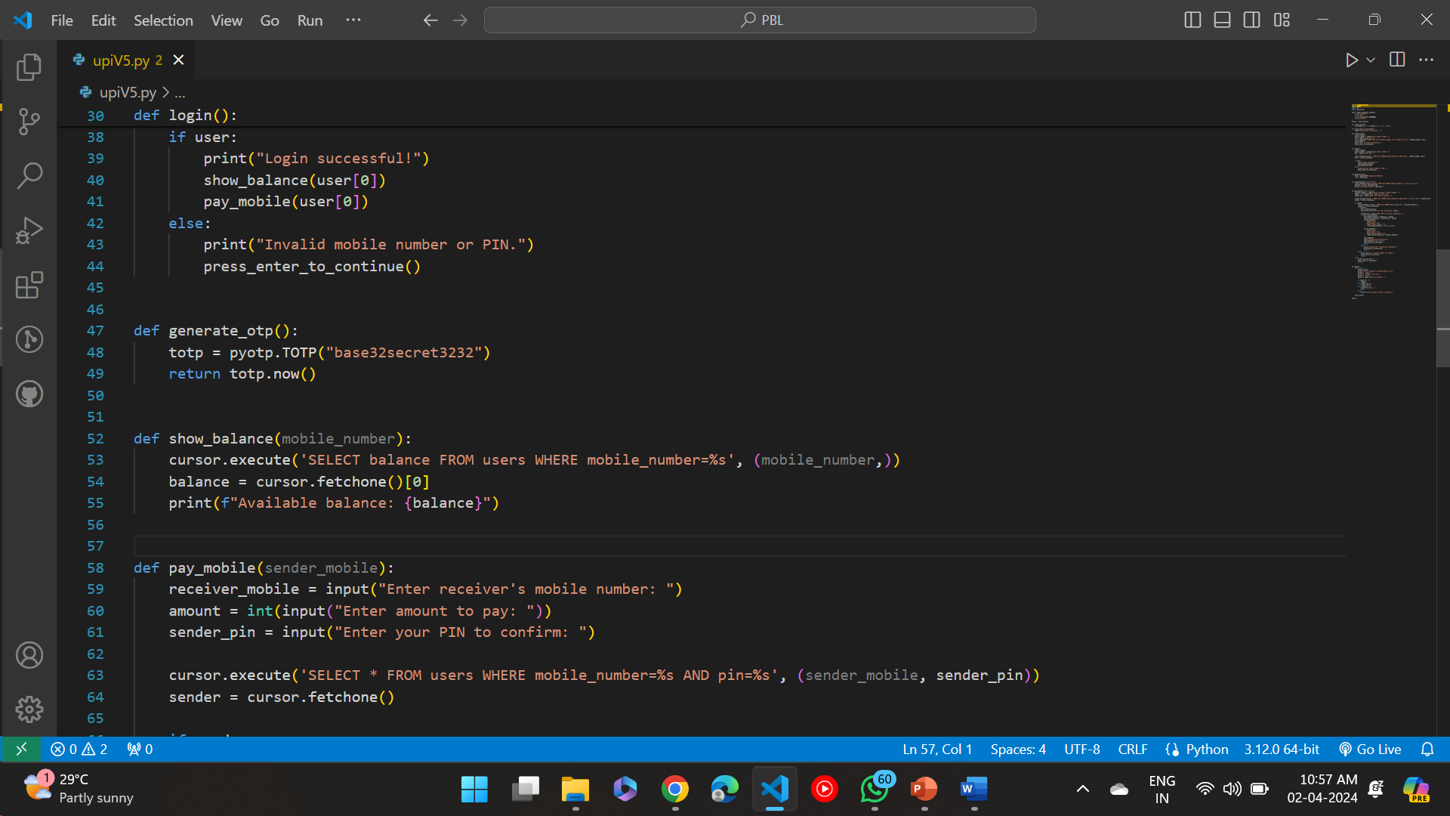

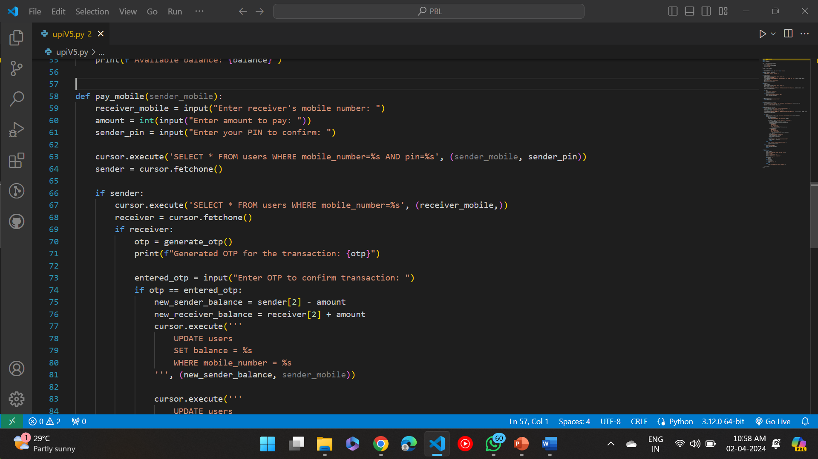

1. **Importing Libraries**:
   * mysql.connector: This library is used to establish a connection between Python and MySQL database.
   * pyotp: This library is used for generating one-time passwords (OTPs) for two-factor authentication.
   * os: This library provides a portable way to interact with the operating system. It is used here to clear the terminal screen.
2. **Establishing Database Connection**:
   * conn = mysql.connector.connect(...): This line establishes a connection to the MySQL database. It requires parameters such as host (the hostname of the database server), user (the username for accessing the database), password (the password for the specified user), and database (the name of the database to connect to).
3. **Creating a Cursor Object**:
   * cursor = conn.cursor(): This line creates a cursor object which is used to execute SQL queries on the connected database.
4. **Utility Functions**:
   * clear_screen(): This function clears the terminal screen. It checks the operating system name and uses the appropriate command to clear the screen.
   * press_enter_to_continue(): This function prompts the user to press Enter to continue the execution of the program.

Overall, this code snippet establishes a connection to a MySQL database, creates a cursor object for executing SQL queries, and defines utility functions for clearing the screen and prompting the user to continue. It sets up the groundwork for interacting with the database within a Python script.

# **ITM Concepts used in the project:-**

ITM encompasses various aspects of managing technology resources and leveraging them to achieve business objectives effectively. Here's how ITM concepts are applied in this project:

1. **Database Management:** We've used MySQL database to store user information such as mobile numbers, PINs, OTP secrets, and balances. Managing this data efficiently is essential for the functioning of the UPI (Unified Payments Interface) application.
2. **Security:** Security is a crucial aspect of ITM. We've implemented user authentication using mobile numbers, PINs, and OTPs to ensure secure access to the application and transactions. Additionally, we've introduced a second login step for the receiver, adding an extra layer of security.
3. **Network Management:** While not explicitly shown in the code, network management concepts are relevant, especially when considering the communication between the application and the database server. Efficient network management ensures smooth data transfer and reliable connectivity.
4. **System Development:** The project involves system development, including designing the application logic, implementing features, and testing functionality. These activities are part of ITM, focusing on developing systems to meet specific business requirements.
5. **User Experience:** Although not directly addressed in the code, user experience (UX) is a critical aspect of ITM. The design choices, user interfaces, and interaction flows impact how users engage with the application and influence their overall experience.

Overall, the project demonstrates the application of ITM concepts to develop and manage a UPI application, addressing aspects such as database management, security, system development, and user experience.